Aliens Theme Cabinet

Purpose
This wiki is to meant to describe how *Epyx* built his Aliens Themed MAME cabinet, provide as much as possible regarding dimensions and layout and eventually store derived cabinets from it.
The source this documentation was extracted from is here: http://forum.arcadecontrols.com/index.php/topic,96465.0.html
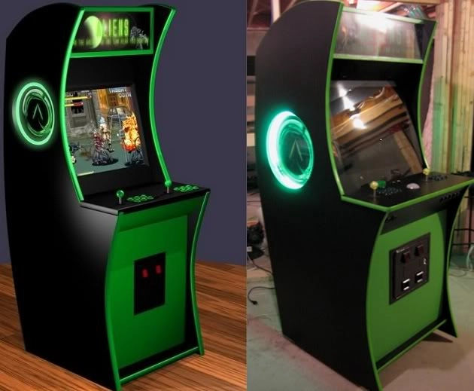
Here is the design vs reality shot the thread starts with:

Structure
The structure is currently vague as we're in the making. Let's see how this turns out.

Available designs
Epyx original design

Extraction details
Just keeping this as a note: to extract all the photos from photobucket I followed the following steps:
- Copy each of the 12 pages URL which contains photos into URL Extractor
  - http://forum.arcadecontrols.com/index.php/topic,96465.0.html
  - http://forum.arcadecontrols.com/index.php/topic,96465.40.html
  - http://forum.arcadecontrols.com/index.php/topic,96465.80.html
  - http://forum.arcadecontrols.com/index.php/topic,96465.120.html
  - http://forum.arcadecontrols.com/index.php/topic,96465.160.html
  - http://forum.arcadecontrols.com/index.php/topic,96465.200.html
  - http://forum.arcadecontrols.com/index.php/topic,96465.240.html
  - http://forum.arcadecontrols.com/index.php/topic,96465.280.html
  - http://forum.arcadecontrols.com/index.php/topic,96465.320.html
  - http://forum.arcadecontrols.com/index.php/topic,96465.360.html
  - http://forum.arcadecontrols.com/index.php/topic,96465.400.html
  - http://forum.arcadecontrols.com/index.php/topic,96465.440.html
- Copy and past the URL Extractor into a text file saved locally and called links.txt
- Filter the newly created links.txt by typing
grep -hr "bb312" links.txt > page[1-12].txt
- Open all tabs from those text files by typing
cat page[1-12].txt | xargs firefox -new-tab
- Save each image using “save image as…” from FireFox into a separate page[1-12] folder
- Convert all those webp images into png using dwebp
for file in *.webp; do dwebp $file "`basename $file`" -o $file.png; done
for f in *.webp.png ; do mv -- "$f" "$(basename -- "$f" .webp.png).png" ; done
- Convert all those png files using imagemagick
mogrify -format jpg *.png
There is probably a way to do all this at once but since it is a one time process I just did it as it came…

Extra design considerations
- Use the cabinet as a Jukebox when not gaming
  - rpi-fruitbox seems nice but not yet working on rpi4
- Get great sound:
  - Great project for rpi2 (is it different on Pi 4?)
  - USB sound connection
  - Some consideration and fixes here

